(2016 WATP Sem 2)
Class Problem
The Perth Wildcats basketball team is two points down and Damien Martin has the ball in centre court. He puts up the shot and scores three points.
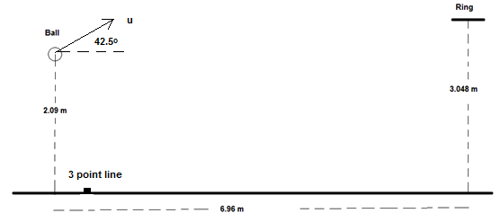

(a) In the space at right, draw a diagram of the ball showing the force/s acting on it whilst in flight. Assume no air resistance. [2 marks]

(b) Martin propels the ball at an angle to the horizontal of 42.5º. What is the initial speed of the ball as shown in the diagram? [6 marks]

(c) Calculate the velocity as it passes through the ring in order to score the three points to win the game. [7 marks]

